Industrial Internship Report on
” music player application”
Prepared by
[Pinjari Mahaboob Basha]

Executive Summary
This report provides details of the Industrial Internship provided by upskill Campus and The IoT Academy in collaboration with Industrial Partner UniConverge Technologies Pvt Ltd (UCT).
This internship was focused on a project/problem statement provided by UCT. We had to finish the project including the report in 6 weeks’ time.
My project was on Prediction of Agriculture Crop Production in india
This internship gave me a very good opportunity to get exposure to Industrial problems and design/implement solution for that. It was an overall great experience to have this internship.

TABLE OF CONTENTS
1 Preface 3
2 Introduction 4
2.1 About UniConverge Technologies Pvt Ltd 4
2.2 About upskill Campus 8
2.3 Objective 9
2.4 Reference 9
2.5 Glossary 10
3 Problem Statement 11
4 Existing and Proposed solution 12
4.1 Code Submission……………………………………………………………………………………………………………………………..13
4.2 Report submission (Github link) ………………………………………………………………………………………………………13
5 Proposed Design/ Model 14
5.1 High Level Diagram (if applicable) 15
5.2 Low Level Diagram (if applicable) 15
5.3 Interfaces (if applicable) 16,17
6 Performance Test 18
6.1 Test Plan/ Test Cases 19
6.2 Test Procedure 19,20
6.3 Performance Outcome 20
7 My learnings 21
8 Future work scope 22

Preface
The Data science and machine learning internship duration was of 6 weeks. 1st week of the internship was to explore the problem statement which were provided by the management and understand their background in order to start with the project. Also learned about UCT. 2nd week of the internship was to understand and follow the project instructions provided by UCT. And, also to plan for the solution of the existing problem. 3rd week of internship is to start for the actual Internships are an opportunity to network with great people and sharpen your skills before entering the workforce. They also help tremendously with figuring out your true passion. Companies often look at them as a way to gain experience and exposure to make a smooth transition into your role when hired.
Agriculture is the main occupation for the people of India, covering 60% of the nation land and catering the basic needs of 1.2 billion people. For the benefit of the farmers, modernization of agriculture procedures is carried out today. The crop yield or production majorly depends on the weather conditions, environmental changes, rainfall (which at times is uncertain), water management, and the utilization of pesticides. Therefore, farmers are not able accomplish expected yield of crop. Now a days data mining, machine learning as well as deep learning approaches are used by various researchers to enhance and improve the yield of crop and their quality. Machine Learning can gain proficiency with the machine without characterized computer programming, so it improves machine execution by distinguishing and portraying the consistency and pattern of drive information. In this work various machine learning approaches such as Linear Regression, Gradient Boosting Regressor, Random Forest Regressor, Decision Tree Regressor, Polynomial Regression, Ridge Regression have been used for yield prediction on crop yield dataset of different states and considering varied crops.
This internship gave me a very good opportunity to get exposure to Industrial problems and design/implement solution for that. It was an overall great experience to have this internship.working of the project. 4th week of the internship was so to continue with the work on the project and check whether there are improvements required for the project. 5th week of the internship was to validate your implementation and evaluate your performance. And the final week of the project is to submit your project report and get certification.

Introduction

About UniConverge Technologies Pvt Ltd
A company established in 2013 and working in Digital Transformation domain and providing Industrial solutions with prime focus on sustainability and RoI.
For developing its products and solutions it is leveraging various Cutting Edge Technologies e.g. Internet of Things (IoT), Cyber Security, Cloud computing (AWS, Azure), Machine Learning, Communication Technologies (4G/5G/LoRaWAN), Java Full Stack, Python, Front end etc.
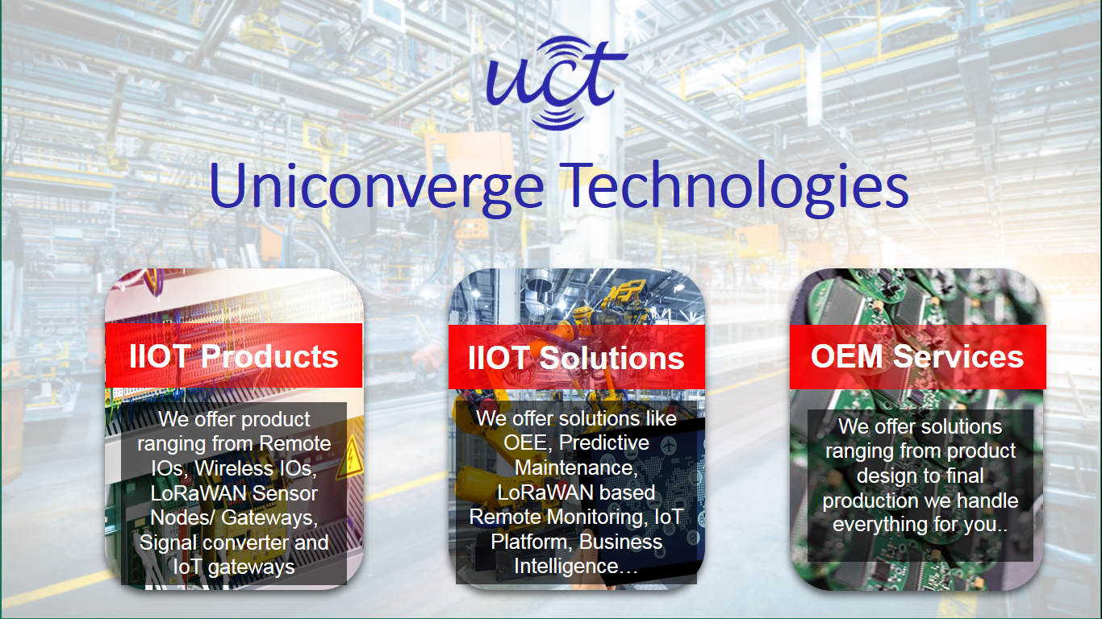
- UCT IoT Platform ()
UCT Insight is an IOT platform designed for quick deployment of IOT applications on the same time providing valuable “insight” for your process/business. It has been built in Java for backend and ReactJS for Front end. It has support for MySQL and various NoSql Databases.
- It enables device connectivity via industry standard IoT protocols - MQTT, CoAP, HTTP, Modbus TCP, OPC UA
- It supports both cloud and on-premises deployments.
It has features to
• Build Your own dashboard
• Analytics and Reporting
• Alert and Notification
• Integration with third party application(Power BI, SAP, ERP)
• Rule Engine

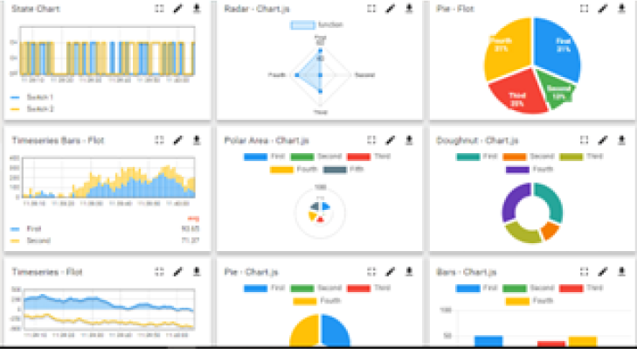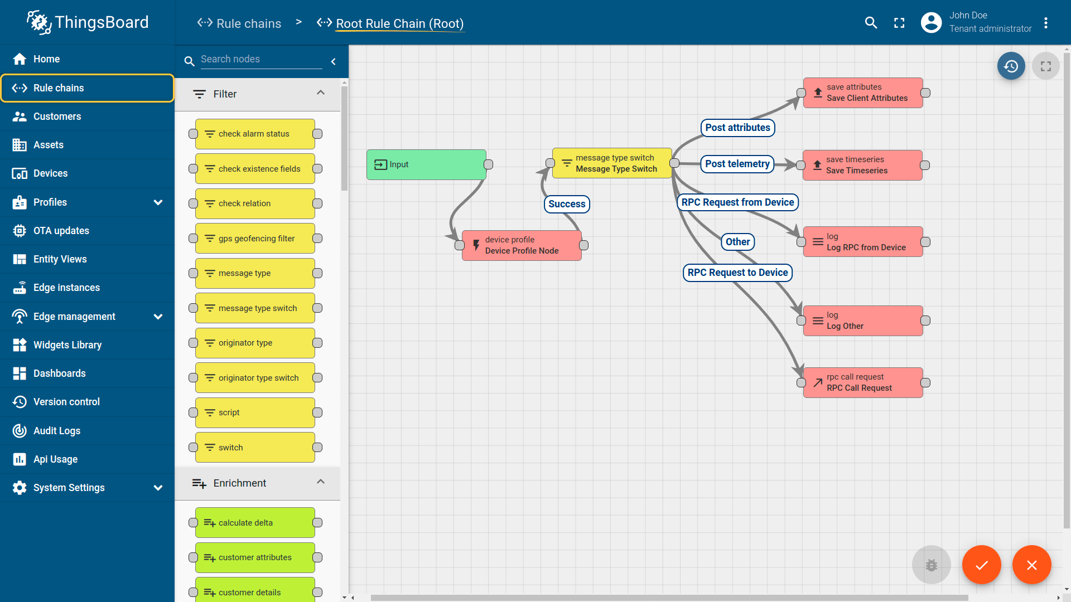

- Smart Factory Platform ()
Factory watch is a platform for smart factory needs.
It provides Users/ Factory
- with a scalable solution for their Production and asset monitoring
- OEE and predictive maintenance solution scaling up to digital twin for your assets.
- to unleased the true potential of the data that their machines are generating and helps to identify the KPIs and also improve them.
- A modular architecture that allows users to choose the service that they what to start and then can scale to more complex solutions as per their demands.
Its unique SaaS model helps users to save time, cost and money.
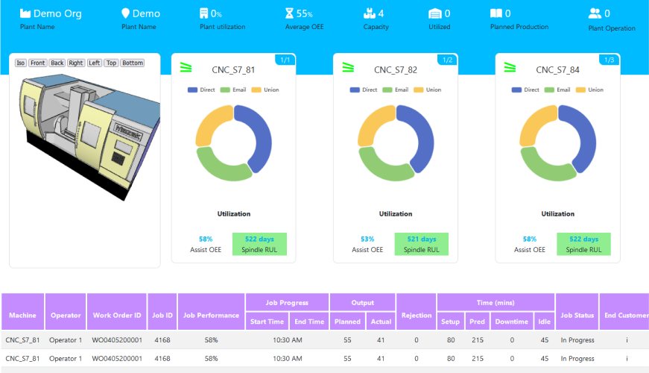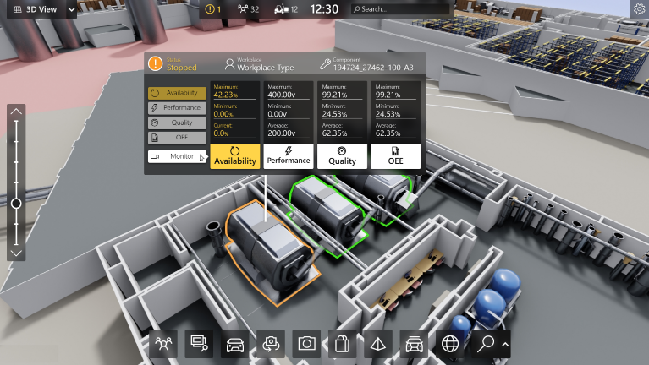

- 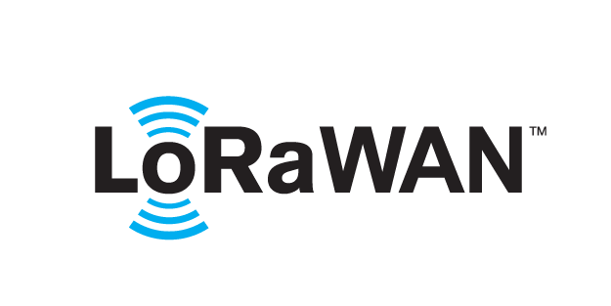 based Solution
UCT is one of the early adopters of LoRAWAN teschnology and providing solution in Agritech, Smart cities, Industrial Monitoring, Smart Street Light, Smart Water/ Gas/ Electricity metering solutions etc.
- Predictive Maintenance
UCT is providing Industrial Machine health monitoring and Predictive maintenance solution leveraging Embedded system, Industrial IoT and Machine Learning Technologies by finding Remaining useful life time of various Machines used in production process.
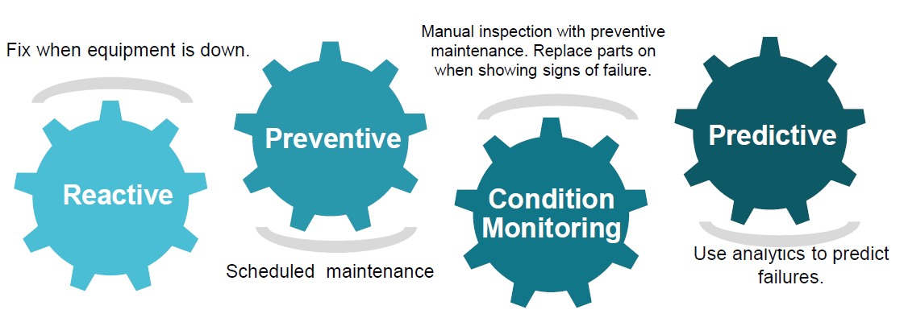

About upskill Campus (USC)
upskill Campus along with The IoT Academy and in association with Uniconverge technologies has facilitated the smooth execution of the complete internship process.
USC is a career development platform that delivers personalized executive coaching in a more affordable, scalable and measurable way.




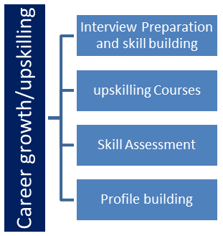
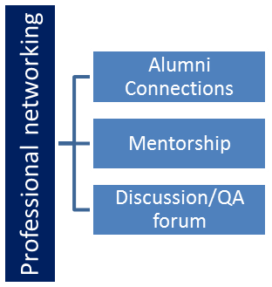
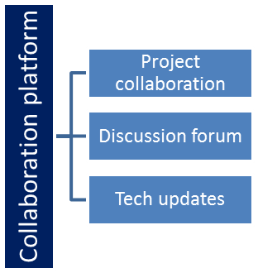
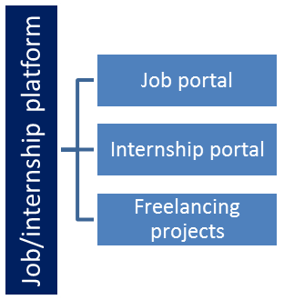

The IoT Academy
The IoT academy is EdTech Division of UCT that is running long executive certification programs in collaboration with EICT Academy, IITK, IITR and IITG in multiple domains.

Objectives of this Internship program
The objective for this internship program was to
☛ get practical experience of working in the industry.
☛ to solve real world problems.
☛ to have improved job prospects.
☛ to have Improved understanding of our field and its applications.
☛ to have Personal growth like better communication and problem solving.

Reference
[1] https://learn.upskillcampus.com/s/courses/6441224de4b0f11fbe0f621e/take
[2] https://drive.google.com/file/d/1zfqvs8-mAO6E0JpgvhBdueNx8Th03pUp/view?usp=sharing
[3] dataset.csv

Glossary
Terms | Acronym
Accuracy | The Number of correct classifcation prediction divided by the the total number of predictor
Confusion Matrix | An NAN table that summarize the number of correct and incorrect prediction that a classification model made
Regression Data | Regression feature are the continous data
Linear Regression | A supervised model which predict the continous data
Matplotlib | An open Source Python 2D plotting library helps you to visualize

Problem Statement
Develop a music player application that allows users to play, manage, and enjoy their music collection. The music player should provide essential functionalities for organizing and playing music files in various formats.
1. Music Playback: Users should be able to play, pause, and stop music playback.
- Output: The music player starts playing the selected song and displays basic playback controls such as play, pause, and stop.

2. Playlist Management: Users should be able to create and manage playlists.
- Output: Users can create a new playlist, add songs to the playlist, and view and modify existing playlists.

3. Music Library Organization: Users should be able to browse and select songs from their music library.
- Output: The music player displays a list of available songs in the library. Users can select a song to play.

4. Basic Navigation: Users should be able to navigate through the music library and playlists.
- Output: Users can browse through their music library, view songs by artist, album, or genre, and switch between different playlists.

5. Audio Control: Users should be able to adjust the volume of the music playback.
- Output: Users can increase or decrease the volume of the music player, and the output audio volume changes accordingly.

The expected output for these minimum features includes a functional music player interface with basic playback controls, the ability to create and manage playlists, the ability to browse and select

Existing and Proposed solution

Existing Solution
Creating a basic music player using Java, JFrame, and ActionListener involves designing a simple graphical user interface (GUI) for controlling music playback. In this example, I'll provide you with a basic outline of how to create a music player with Play, Pause, and Stop buttons using Java's Swing library and the ActionListener interface.
- Import the required packages. This includes the swing package for creating the user interface, the awt package for basic graphical components, and the java.io package for file handling.
- Initialize the user interface. This includes creating a JFrame object, adding buttons for playing, pausing, stopping, and selecting a song, and adding a label to display the current song.
- Add action listeners to the buttons. This will allow the buttons to perform their respective actions when clicked.
- Play the music. This can be done by creating a Clip object and calling its start() method.
- Handle events. This includes handling events such as the user clicking on a button or the music finishing playing.

SOURCE CODE AND IMPLEMENTATION:
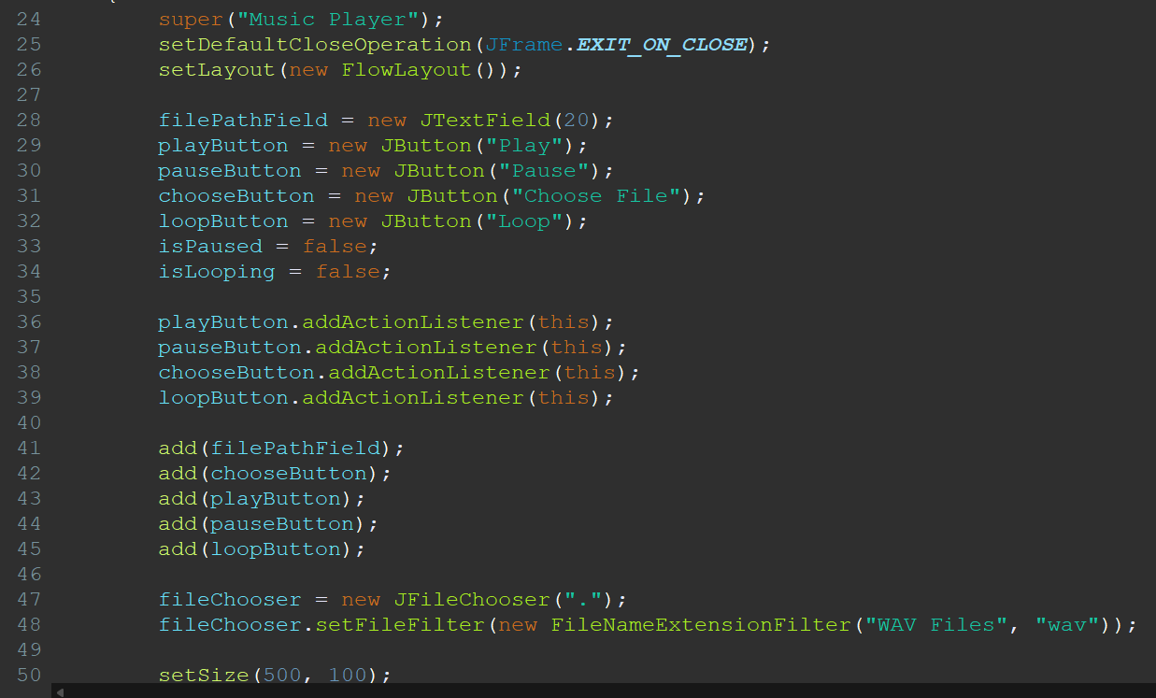

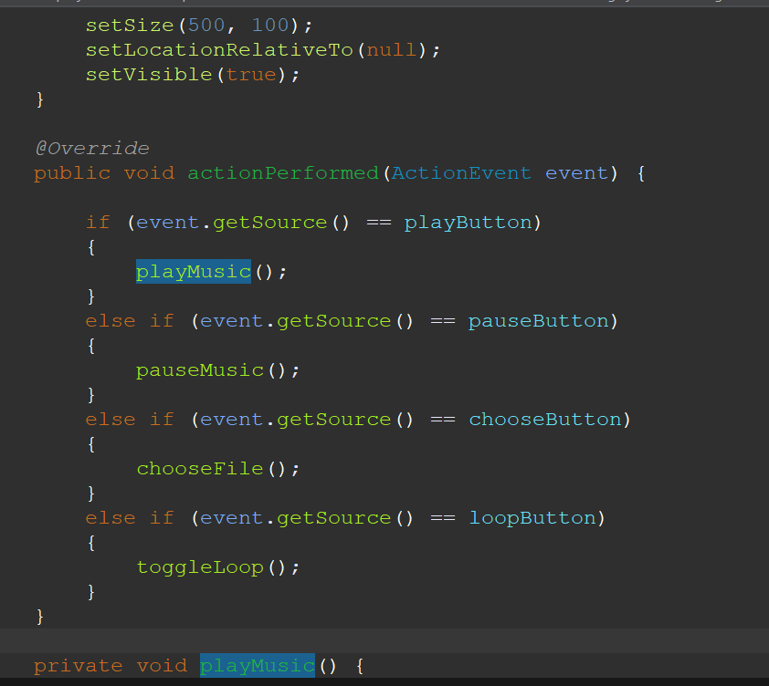
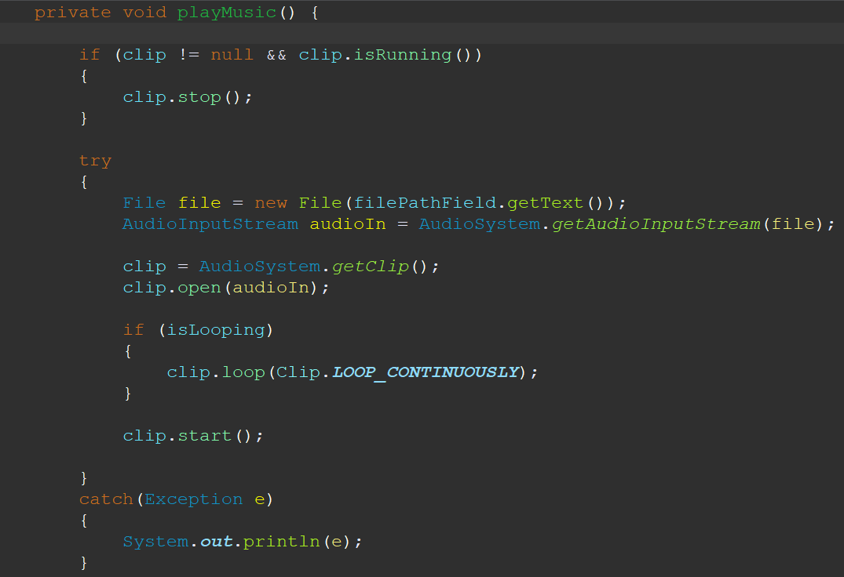
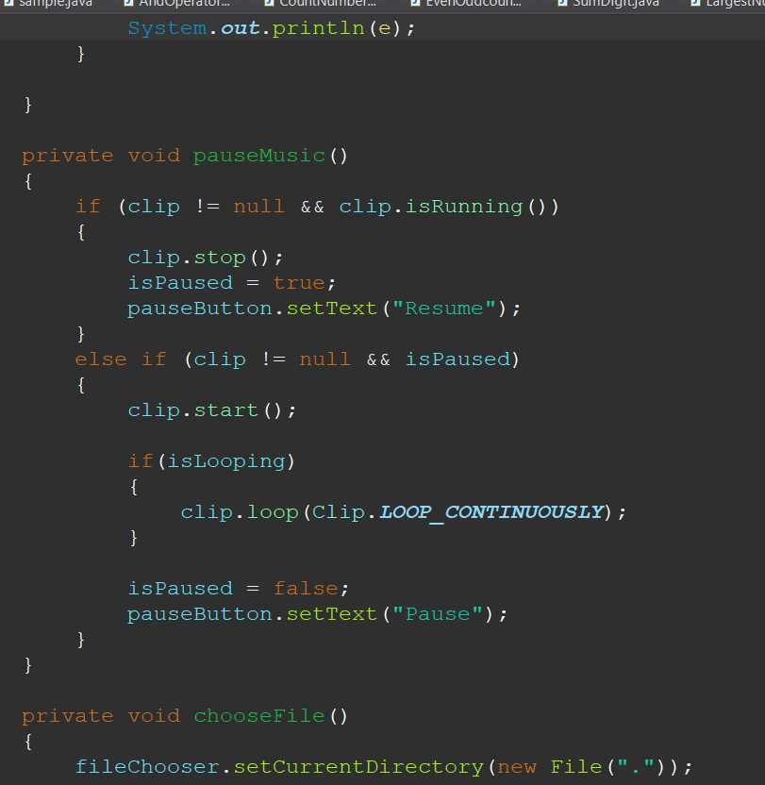
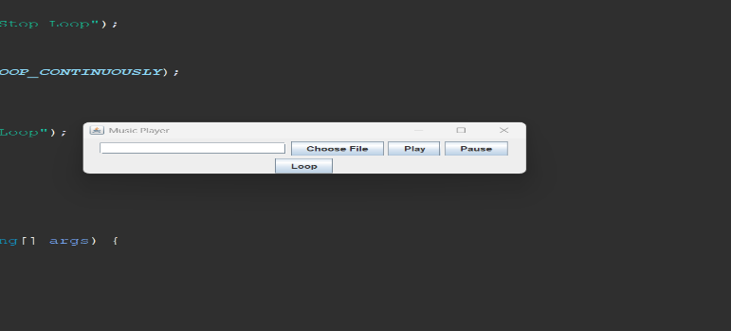

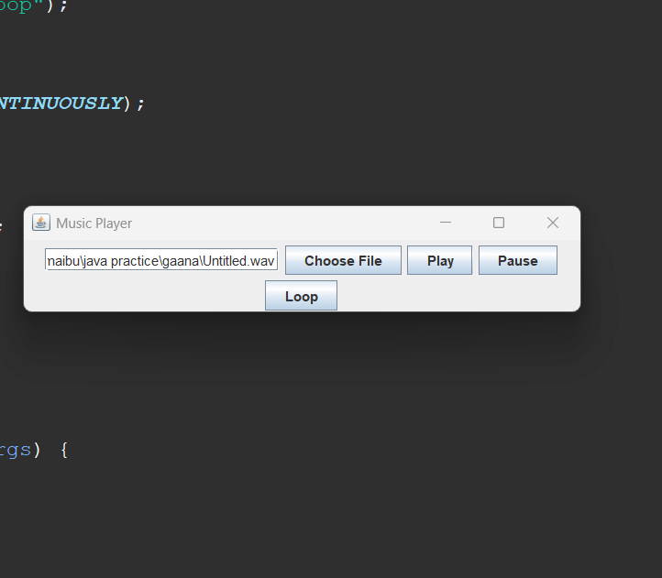

Code submission (Github link):
https://github.com/Mahaboob3692/UpSkill-Campus/blob/main/music%20player%20application_MahaboobBasha_USC_UCT/src/gaana/JavaGaanaJFrame.java

Report submission (Github link) : first make placeholder, copy the link.

My learnings
This week, I worked on the following tasks:
● Completed the user research for the new website redesign.
● Implemented the new user interface for the website.
● Resolved a bug in the checkout process.
Milestones Achieved
● The user research for the new website redesign is complete.
● The new user interface for the website has been implemented.
● The bug in the checkout process has been resolved.
Significant Contributions
● I played a key role in the user research for the new website redesign. I
conducted interviews with users and analyzed their feedback. This feedback was
used to inform the design of the new website.
● I also implemented the new user interface for the website. I worked closely with
the design team to ensure that the interface was user-friendly and met the needs
of our users.
● I also resolved a bug in the checkout process. This bug was preventing users
from completing their purchases. I was able to identify the cause of the bug and
implement a fix.
Challenges and Hurdles
● One challenge I faced this week was the tight deadline for the new website
redesign. We had to get the new website launched by the end of the month, so
we were under a lot of pressure to get the work done on time.
● Another challenge I faced was the lack of resources. We were short-staffed, so I
had to wear many hats and take on more responsibility than I normally would.
Lessons Learned
● I learned the importance of time management. I had to learn how to prioritize my
tasks and work efficiently in order to meet the tight deadline
I also learned the importance of teamwork. I had to work closely with the design
team and other developers to get the new website redesign done on time.
Next Steps
● Next week, I will continue working on the new website redesign. I will be testing
the new website with users to make sure it is user-friendly and meets their
needs.
● I will also be working on the development of a new mobile app.
I am confident that I can continue to make significant contributions to the team and help
us achieve our goals.



